MBASalaries Code.R

Purbasha Chatterjee

[pchatterjee10@gmail.com](mailto:pchatterjee10@gmail.com)

Oregon State University, Corvallis

Wed Jul 05 15:33:46 2017

# Analysis of MBA Starting Salaries  
# NAME: Purbasha Chatterjee  
# EMAIL: pchatterjee10@gmail.com  
# COLLEGE : Oregon State University, Corvallis  
  
setwd('C:/Users/purba/Desktop/R')  
  
mba_Sal.df <- read.csv(paste("MBA Starting Salaries Data.csv", sep=""))  
summary(mba_Sal.df)

## age sex gmat_tot gmat_qpc   
## Min. :22.00 Min. :1.000 Min. :450.0 Min. :28.00   
## 1st Qu.:25.00 1st Qu.:1.000 1st Qu.:580.0 1st Qu.:72.00   
## Median :27.00 Median :1.000 Median :620.0 Median :83.00   
## Mean :27.36 Mean :1.248 Mean :619.5 Mean :80.64   
## 3rd Qu.:29.00 3rd Qu.:1.000 3rd Qu.:660.0 3rd Qu.:93.00   
## Max. :48.00 Max. :2.000 Max. :790.0 Max. :99.00   
## gmat_vpc gmat_tpc s_avg f_avg   
## Min. :16.00 Min. : 0.0 Min. :2.000 Min. :0.000   
## 1st Qu.:71.00 1st Qu.:78.0 1st Qu.:2.708 1st Qu.:2.750   
## Median :81.00 Median :87.0 Median :3.000 Median :3.000   
## Mean :78.32 Mean :84.2 Mean :3.025 Mean :3.062   
## 3rd Qu.:91.00 3rd Qu.:94.0 3rd Qu.:3.300 3rd Qu.:3.250   
## Max. :99.00 Max. :99.0 Max. :4.000 Max. :4.000   
## quarter work_yrs frstlang salary   
## Min. :1.000 Min. : 0.000 Min. :1.000 Min. : 0   
## 1st Qu.:1.250 1st Qu.: 2.000 1st Qu.:1.000 1st Qu.: 0   
## Median :2.000 Median : 3.000 Median :1.000 Median : 999   
## Mean :2.478 Mean : 3.872 Mean :1.117 Mean : 39026   
## 3rd Qu.:3.000 3rd Qu.: 4.000 3rd Qu.:1.000 3rd Qu.: 97000   
## Max. :4.000 Max. :22.000 Max. :2.000 Max. :220000   
## satis   
## Min. : 1.0   
## 1st Qu.: 5.0   
## Median : 6.0   
## Mean :172.2   
## 3rd Qu.: 7.0   
## Max. :998.0

counts <- table(mba_Sal.df$gmat_tot)  
barplot(counts, main = "GMAT TOTAL Distribution")

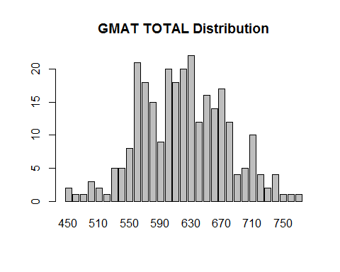

#if (!(mba_Sal.df$salary =998) && !(mba_Sal.df$salary =999)){  
counts <- table(mba_Sal.df$salary)  
barplot(counts, main = "SALARY Distribution")

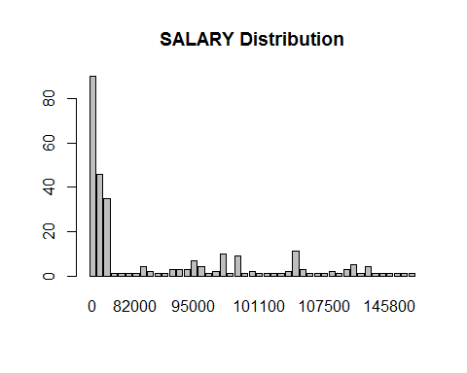

counts <- table(mba_Sal.df$work_yrs)  
barplot(counts, main = "WORK EXPERIENCE Distribution")

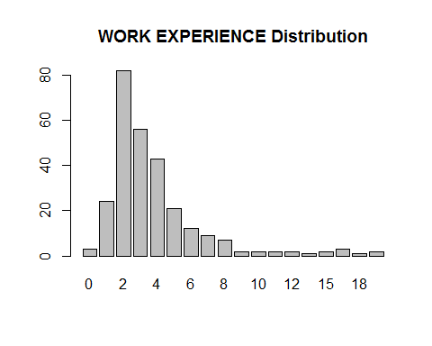

counts <- table(mba_Sal.df$age)  
barplot(counts, main = "AGE Distribution")  
  
  
library(car)

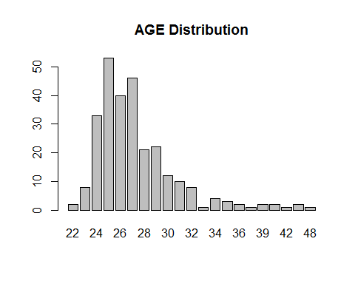

par(mfrow=c(3, 3))  
with(mba_Sal.df, scatterplot(mba_Sal.df$sex , mba_Sal.df$satis))

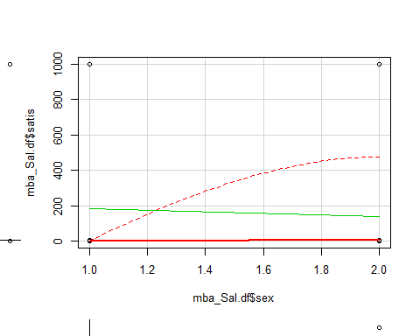

with(mba_Sal.df, scatterplot(mba_Sal.df$frstlang , mba_Sal.df$gmat_vpc))

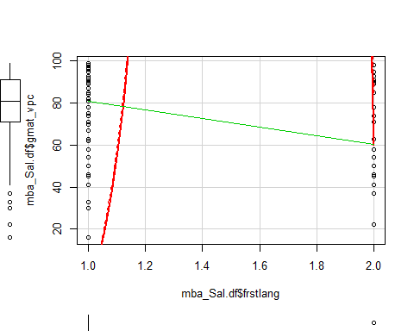

with(mba_Sal.df, scatterplot(mba_Sal.df$f_avg , mba_Sal.df$s_avg))

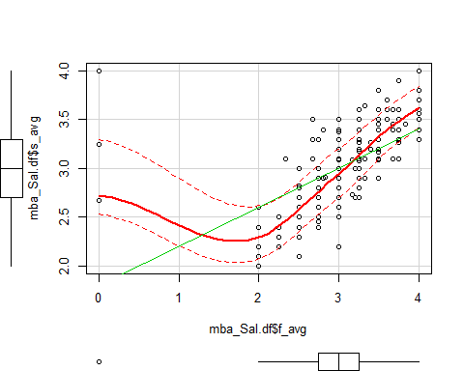

with(mba_Sal.df, scatterplot(mba_Sal.df$quarter , mba_Sal.df$salary))

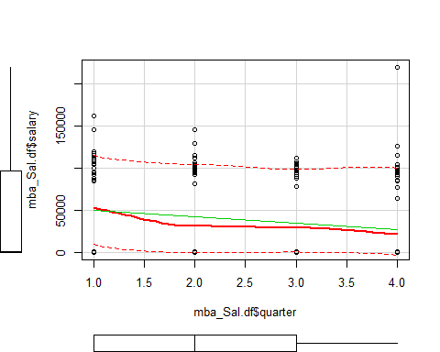

placed <- mba_Sal.df[ which(mba_Sal.df$salary>0 & mba_Sal.df$salary!=998 & mba_Sal.df$salary!=999) , ]   
  
placedtable <- xtabs(~ placed$gmat_tot+placed$f_avg, data=placed)  
View(placedtable)  
prop.table(placedtable)

## placed$f_avg  
## placed$gmat_tot 0 2 2.25 2.5  
## 500 0.000000000 0.000000000 0.000000000 0.000000000  
## 520 0.000000000 0.000000000 0.000000000 0.000000000  
## 530 0.000000000 0.000000000 0.000000000 0.000000000  
## 540 0.000000000 0.000000000 0.000000000 0.009708738  
## 550 0.000000000 0.000000000 0.000000000 0.000000000  
## 560 0.000000000 0.000000000 0.000000000 0.000000000  
## 570 0.000000000 0.000000000 0.000000000 0.009708738  
## 580 0.000000000 0.009708738 0.000000000 0.000000000  
## 590 0.000000000 0.000000000 0.000000000 0.000000000  
## 600 0.000000000 0.000000000 0.000000000 0.009708738  
## 610 0.000000000 0.000000000 0.000000000 0.000000000  
## 620 0.000000000 0.009708738 0.000000000 0.000000000  
## 630 0.009708738 0.000000000 0.000000000 0.019417476  
## 640 0.000000000 0.000000000 0.000000000 0.000000000  
## 650 0.000000000 0.000000000 0.009708738 0.000000000  
## 660 0.000000000 0.000000000 0.000000000 0.000000000  
## 670 0.000000000 0.000000000 0.000000000 0.000000000  
## 680 0.000000000 0.000000000 0.000000000 0.000000000  
## 700 0.000000000 0.000000000 0.000000000 0.000000000  
## 710 0.000000000 0.000000000 0.000000000 0.000000000  
## 720 0.000000000 0.000000000 0.000000000 0.000000000  
## placed$f_avg  
## placed$gmat_tot 2.67 2.75 2.83 3  
## 500 0.000000000 0.019417476 0.000000000 0.000000000  
## 520 0.000000000 0.009708738 0.000000000 0.000000000  
## 530 0.000000000 0.009708738 0.000000000 0.000000000  
## 540 0.000000000 0.000000000 0.000000000 0.009708738  
## 550 0.000000000 0.009708738 0.000000000 0.009708738  
## 560 0.000000000 0.000000000 0.000000000 0.029126214  
## 570 0.000000000 0.009708738 0.000000000 0.009708738  
## 580 0.000000000 0.000000000 0.009708738 0.019417476  
## 590 0.000000000 0.000000000 0.000000000 0.000000000  
## 600 0.000000000 0.000000000 0.000000000 0.029126214  
## 610 0.000000000 0.019417476 0.000000000 0.009708738  
## 620 0.000000000 0.019417476 0.000000000 0.038834951  
## 630 0.000000000 0.019417476 0.000000000 0.009708738  
## 640 0.000000000 0.000000000 0.000000000 0.000000000  
## 650 0.000000000 0.000000000 0.000000000 0.029126214  
## 660 0.000000000 0.000000000 0.000000000 0.019417476  
## 670 0.000000000 0.009708738 0.000000000 0.009708738  
## 680 0.009708738 0.019417476 0.000000000 0.009708738  
## 700 0.000000000 0.000000000 0.000000000 0.000000000  
## 710 0.000000000 0.000000000 0.000000000 0.009708738  
## 720 0.000000000 0.000000000 0.000000000 0.000000000  
## placed$f_avg  
## placed$gmat_tot 3.25 3.33 3.5 3.6  
## 500 0.000000000 0.000000000 0.000000000 0.000000000  
## 520 0.000000000 0.000000000 0.000000000 0.000000000  
## 530 0.000000000 0.000000000 0.000000000 0.000000000  
## 540 0.000000000 0.000000000 0.000000000 0.000000000  
## 550 0.000000000 0.000000000 0.009708738 0.000000000  
## 560 0.029126214 0.000000000 0.009708738 0.000000000  
## 570 0.009708738 0.000000000 0.019417476 0.000000000  
## 580 0.029126214 0.000000000 0.009708738 0.000000000  
## 590 0.019417476 0.000000000 0.000000000 0.000000000  
## 600 0.029126214 0.000000000 0.019417476 0.000000000  
## 610 0.009708738 0.000000000 0.009708738 0.000000000  
## 620 0.009708738 0.000000000 0.029126214 0.000000000  
## 630 0.019417476 0.000000000 0.000000000 0.000000000  
## 640 0.000000000 0.000000000 0.009708738 0.000000000  
## 650 0.019417476 0.000000000 0.009708738 0.000000000  
## 660 0.009708738 0.000000000 0.009708738 0.000000000  
## 670 0.029126214 0.009708738 0.009708738 0.000000000  
## 680 0.009708738 0.000000000 0.000000000 0.009708738  
## 700 0.009708738 0.000000000 0.000000000 0.000000000  
## 710 0.009708738 0.000000000 0.019417476 0.000000000  
## 720 0.000000000 0.000000000 0.000000000 0.009708738  
## placed$f_avg  
## placed$gmat_tot 3.67 3.75 4  
## 500 0.000000000 0.000000000 0.000000000  
## 520 0.000000000 0.000000000 0.000000000  
## 530 0.009708738 0.000000000 0.000000000  
## 540 0.000000000 0.000000000 0.000000000  
## 550 0.000000000 0.000000000 0.000000000  
## 560 0.009708738 0.000000000 0.000000000  
## 570 0.000000000 0.000000000 0.009708738  
## 580 0.000000000 0.000000000 0.000000000  
## 590 0.000000000 0.000000000 0.000000000  
## 600 0.000000000 0.000000000 0.000000000  
## 610 0.000000000 0.000000000 0.000000000  
## 620 0.000000000 0.009708738 0.000000000  
## 630 0.000000000 0.000000000 0.000000000  
## 640 0.000000000 0.000000000 0.000000000  
## 650 0.000000000 0.000000000 0.000000000  
## 660 0.000000000 0.009708738 0.000000000  
## 670 0.000000000 0.000000000 0.000000000  
## 680 0.000000000 0.000000000 0.000000000  
## 700 0.000000000 0.009708738 0.009708738  
## 710 0.000000000 0.000000000 0.000000000  
## 720 0.000000000 0.000000000 0.000000000

chisq.test(placedtable)

## Warning in chisq.test(placedtable): Chi-squared approximation may be  
## incorrect

##   
## Pearson's Chi-squared test  
##   
## data: placedtable  
## X-squared = 288.04, df = 280, p-value = 0.3578

placedtable <- xtabs(~ placed$s_avg+placed$f_avg, data=placed)  
View(placedtable)  
prop.table(placedtable)

## placed$f_avg  
## placed$s_avg 0 2 2.25 2.5 2.67  
## 2.2 0.000000000 0.009708738 0.000000000 0.000000000 0.000000000  
## 2.3 0.000000000 0.000000000 0.000000000 0.009708738 0.000000000  
## 2.4 0.000000000 0.009708738 0.009708738 0.000000000 0.000000000  
## 2.5 0.000000000 0.000000000 0.000000000 0.009708738 0.000000000  
## 2.6 0.000000000 0.000000000 0.000000000 0.019417476 0.000000000  
## 2.7 0.000000000 0.000000000 0.000000000 0.009708738 0.000000000  
## 2.8 0.000000000 0.000000000 0.000000000 0.000000000 0.000000000  
## 2.9 0.000000000 0.000000000 0.000000000 0.000000000 0.000000000  
## 2.91 0.000000000 0.000000000 0.000000000 0.000000000 0.000000000  
## 3 0.000000000 0.000000000 0.000000000 0.000000000 0.000000000  
## 3.09 0.000000000 0.000000000 0.000000000 0.000000000 0.000000000  
## 3.1 0.000000000 0.000000000 0.000000000 0.000000000 0.000000000  
## 3.2 0.000000000 0.000000000 0.000000000 0.000000000 0.000000000  
## 3.27 0.000000000 0.000000000 0.000000000 0.000000000 0.000000000  
## 3.3 0.000000000 0.000000000 0.000000000 0.000000000 0.000000000  
## 3.4 0.000000000 0.000000000 0.000000000 0.000000000 0.000000000  
## 3.45 0.000000000 0.000000000 0.000000000 0.000000000 0.000000000  
## 3.5 0.000000000 0.000000000 0.000000000 0.000000000 0.009708738  
## 3.6 0.000000000 0.000000000 0.000000000 0.000000000 0.000000000  
## 3.7 0.000000000 0.000000000 0.000000000 0.000000000 0.000000000  
## 3.8 0.000000000 0.000000000 0.000000000 0.000000000 0.000000000  
## 4 0.009708738 0.000000000 0.000000000 0.000000000 0.000000000  
## placed$f_avg  
## placed$s_avg 2.75 2.83 3 3.25 3.33  
## 2.2 0.000000000 0.000000000 0.000000000 0.000000000 0.000000000  
## 2.3 0.000000000 0.000000000 0.000000000 0.000000000 0.000000000  
## 2.4 0.019417476 0.000000000 0.000000000 0.000000000 0.000000000  
## 2.5 0.009708738 0.000000000 0.009708738 0.000000000 0.000000000  
## 2.6 0.019417476 0.000000000 0.019417476 0.000000000 0.000000000  
## 2.7 0.019417476 0.000000000 0.009708738 0.000000000 0.000000000  
## 2.8 0.029126214 0.000000000 0.029126214 0.009708738 0.000000000  
## 2.9 0.029126214 0.000000000 0.048543689 0.038834951 0.000000000  
## 2.91 0.000000000 0.009708738 0.000000000 0.000000000 0.000000000  
## 3 0.019417476 0.000000000 0.019417476 0.019417476 0.000000000  
## 3.09 0.000000000 0.000000000 0.009708738 0.000000000 0.000000000  
## 3.1 0.000000000 0.000000000 0.038834951 0.000000000 0.009708738  
## 3.2 0.000000000 0.000000000 0.019417476 0.058252427 0.000000000  
## 3.27 0.000000000 0.000000000 0.000000000 0.009708738 0.000000000  
## 3.3 0.000000000 0.000000000 0.009708738 0.058252427 0.000000000  
## 3.4 0.000000000 0.000000000 0.009708738 0.019417476 0.000000000  
## 3.45 0.000000000 0.000000000 0.000000000 0.000000000 0.000000000  
## 3.5 0.000000000 0.000000000 0.019417476 0.029126214 0.000000000  
## 3.6 0.000000000 0.000000000 0.000000000 0.000000000 0.000000000  
## 3.7 0.000000000 0.000000000 0.000000000 0.000000000 0.000000000  
## 3.8 0.000000000 0.000000000 0.000000000 0.000000000 0.000000000  
## 4 0.000000000 0.000000000 0.000000000 0.000000000 0.000000000  
## placed$f_avg  
## placed$s_avg 3.5 3.6 3.67 3.75 4  
## 2.2 0.000000000 0.000000000 0.000000000 0.000000000 0.000000000  
## 2.3 0.000000000 0.000000000 0.000000000 0.000000000 0.000000000  
## 2.4 0.000000000 0.000000000 0.000000000 0.000000000 0.000000000  
## 2.5 0.000000000 0.000000000 0.000000000 0.000000000 0.000000000  
## 2.6 0.000000000 0.000000000 0.000000000 0.000000000 0.000000000  
## 2.7 0.000000000 0.000000000 0.000000000 0.000000000 0.000000000  
## 2.8 0.000000000 0.000000000 0.000000000 0.000000000 0.000000000  
## 2.9 0.009708738 0.000000000 0.000000000 0.000000000 0.000000000  
## 2.91 0.000000000 0.000000000 0.000000000 0.000000000 0.000000000  
## 3 0.000000000 0.000000000 0.000000000 0.000000000 0.000000000  
## 3.09 0.009708738 0.000000000 0.000000000 0.000000000 0.000000000  
## 3.1 0.019417476 0.000000000 0.000000000 0.000000000 0.000000000  
## 3.2 0.009708738 0.000000000 0.000000000 0.000000000 0.000000000  
## 3.27 0.000000000 0.000000000 0.000000000 0.000000000 0.000000000  
## 3.3 0.038834951 0.000000000 0.000000000 0.000000000 0.000000000  
## 3.4 0.000000000 0.000000000 0.009708738 0.009708738 0.000000000  
## 3.45 0.009708738 0.000000000 0.000000000 0.000000000 0.000000000  
## 3.5 0.019417476 0.009708738 0.000000000 0.009708738 0.000000000  
## 3.6 0.038834951 0.000000000 0.009708738 0.009708738 0.000000000  
## 3.7 0.000000000 0.009708738 0.000000000 0.000000000 0.009708738  
## 3.8 0.009708738 0.000000000 0.000000000 0.000000000 0.009708738  
## 4 0.000000000 0.000000000 0.000000000 0.000000000 0.000000000

chisq.test(placedtable)

## Warning in chisq.test(placedtable): Chi-squared approximation may be  
## incorrect

##   
## Pearson's Chi-squared test  
##   
## data: placedtable  
## X-squared = 551.43, df = 294, p-value < 2.2e-16

placedtable <- xtabs(~ placed$work_yrs+placed$f_avg, data=placed)  
View(placedtable)  
prop.table(placedtable)

## placed$f_avg  
## placed$work_yrs 0 2 2.25 2.5  
## 0 0.000000000 0.000000000 0.000000000 0.000000000  
## 1 0.000000000 0.000000000 0.000000000 0.000000000  
## 2 0.000000000 0.019417476 0.000000000 0.029126214  
## 3 0.000000000 0.000000000 0.000000000 0.019417476  
## 4 0.000000000 0.000000000 0.000000000 0.000000000  
## 5 0.000000000 0.000000000 0.009708738 0.000000000  
## 6 0.000000000 0.000000000 0.000000000 0.000000000  
## 7 0.000000000 0.000000000 0.000000000 0.000000000  
## 8 0.000000000 0.000000000 0.000000000 0.000000000  
## 10 0.000000000 0.000000000 0.000000000 0.000000000  
## 15 0.009708738 0.000000000 0.000000000 0.000000000  
## 16 0.000000000 0.000000000 0.000000000 0.000000000  
## placed$f_avg  
## placed$work_yrs 2.67 2.75 2.83 3  
## 0 0.000000000 0.000000000 0.000000000 0.000000000  
## 1 0.000000000 0.009708738 0.000000000 0.000000000  
## 2 0.009708738 0.048543689 0.009708738 0.077669903  
## 3 0.000000000 0.038834951 0.000000000 0.048543689  
## 4 0.000000000 0.029126214 0.000000000 0.038834951  
## 5 0.000000000 0.000000000 0.000000000 0.019417476  
## 6 0.000000000 0.009708738 0.000000000 0.019417476  
## 7 0.000000000 0.000000000 0.000000000 0.000000000  
## 8 0.000000000 0.000000000 0.000000000 0.029126214  
## 10 0.000000000 0.000000000 0.000000000 0.000000000  
## 15 0.000000000 0.009708738 0.000000000 0.000000000  
## 16 0.000000000 0.000000000 0.000000000 0.009708738  
## placed$f_avg  
## placed$work_yrs 3.25 3.33 3.5 3.6  
## 0 0.009708738 0.000000000 0.000000000 0.000000000  
## 1 0.009708738 0.009708738 0.029126214 0.000000000  
## 2 0.097087379 0.000000000 0.067961165 0.000000000  
## 3 0.058252427 0.000000000 0.019417476 0.009708738  
## 4 0.029126214 0.000000000 0.000000000 0.000000000  
## 5 0.019417476 0.000000000 0.000000000 0.000000000  
## 6 0.000000000 0.000000000 0.029126214 0.009708738  
## 7 0.009708738 0.000000000 0.000000000 0.000000000  
## 8 0.009708738 0.000000000 0.000000000 0.000000000  
## 10 0.000000000 0.000000000 0.009708738 0.000000000  
## 15 0.000000000 0.000000000 0.000000000 0.000000000  
## 16 0.000000000 0.000000000 0.009708738 0.000000000  
## placed$f_avg  
## placed$work_yrs 3.67 3.75 4  
## 0 0.000000000 0.000000000 0.000000000  
## 1 0.000000000 0.019417476 0.000000000  
## 2 0.009708738 0.000000000 0.000000000  
## 3 0.009708738 0.000000000 0.000000000  
## 4 0.000000000 0.000000000 0.009708738  
## 5 0.000000000 0.009708738 0.009708738  
## 6 0.000000000 0.000000000 0.000000000  
## 7 0.000000000 0.000000000 0.000000000  
## 8 0.000000000 0.000000000 0.000000000  
## 10 0.000000000 0.000000000 0.000000000  
## 15 0.000000000 0.000000000 0.000000000  
## 16 0.000000000 0.000000000 0.000000000

chisq.test(placedtable)

## Warning in chisq.test(placedtable): Chi-squared approximation may be  
## incorrect

##   
## Pearson's Chi-squared test  
##   
## data: placedtable  
## X-squared = 164.05, df = 154, p-value = 0.2747

placedtable <- xtabs(~ placed$frstlang+placed$gmat_vpc, data=placed)  
View(placedtable)  
prop.table(placedtable)

## placed$gmat_vpc  
## placed$frstlang 30 33 37 45  
## 1 0.009708738 0.009708738 0.000000000 0.009708738  
## 2 0.000000000 0.000000000 0.009708738 0.019417476  
## placed$gmat_vpc  
## placed$frstlang 50 54 58 62  
## 1 0.019417476 0.009708738 0.038834951 0.038834951  
## 2 0.000000000 0.000000000 0.009708738 0.000000000  
## placed$gmat_vpc  
## placed$frstlang 63 67 71 74  
## 1 0.009708738 0.058252427 0.087378641 0.067961165  
## 2 0.000000000 0.000000000 0.000000000 0.000000000  
## placed$gmat_vpc  
## placed$frstlang 75 78 81 84  
## 1 0.009708738 0.019417476 0.106796117 0.048543689  
## 2 0.000000000 0.000000000 0.000000000 0.000000000  
## placed$gmat_vpc  
## placed$frstlang 87 89 90 91  
## 1 0.067961165 0.029126214 0.009708738 0.029126214  
## 2 0.000000000 0.009708738 0.009708738 0.000000000  
## placed$gmat_vpc  
## placed$frstlang 92 93 95 96  
## 1 0.019417476 0.038834951 0.058252427 0.048543689  
## 2 0.000000000 0.000000000 0.009708738 0.000000000  
## placed$gmat_vpc  
## placed$frstlang 97 98 99  
## 1 0.009708738 0.067961165 0.009708738  
## 2 0.000000000 0.000000000 0.000000000

chisq.test(placedtable)

## Warning in chisq.test(placedtable): Chi-squared approximation may be  
## incorrect

##   
## Pearson's Chi-squared test  
##   
## data: placedtable  
## X-squared = 46.58, df = 26, p-value = 0.007852

t.test(placed$gmat_vpc, placed$frstlang)

##   
## Welch Two Sample t-test  
##   
## data: placed$gmat_vpc and placed$frstlang  
## t = 48.708, df = 102.05, p-value < 2.2e-16  
## alternative hypothesis: true difference in means is not equal to 0  
## 95 percent confidence interval:  
## 74.33941 80.65088  
## sample estimates:  
## mean of x mean of y   
## 78.563107 1.067961

t.test(placed$f_avg, placed$salary)

##   
## Welch Two Sample t-test  
##   
## data: placed$f_avg and placed$salary  
## t = -58.516, df = 102, p-value < 2.2e-16  
## alternative hypothesis: true difference in means is not equal to 0  
## 95 percent confidence interval:  
## -106519.92 -99535.38  
## sample estimates:  
## mean of x mean of y   
## 3.090971e+00 1.030307e+05

t.test(placed$s_avg, placed$salary)

##   
## Welch Two Sample t-test  
##   
## data: placed$s_avg and placed$salary  
## t = -58.516, df = 102, p-value < 2.2e-16  
## alternative hypothesis: true difference in means is not equal to 0  
## 95 percent confidence interval:  
## -106519.92 -99535.37  
## sample estimates:  
## mean of x mean of y   
## 3.09233 103030.73786

t.test(placed$age, placed$work_yrs)

##   
## Welch Two Sample t-test  
##   
## data: placed$age and placed$work_yrs  
## t = 52.723, df = 202.6, p-value < 2.2e-16  
## alternative hypothesis: true difference in means is not equal to 0  
## 95 percent confidence interval:  
## 22.23330 23.96088  
## sample estimates:  
## mean of x mean of y   
## 26.776699 3.679612

t.test(placed$work_yrs, placed$salary)

##   
## Welch Two Sample t-test  
##   
## data: placed$work_yrs and placed$salary  
## t = -58.516, df = 102, p-value < 2.2e-16  
## alternative hypothesis: true difference in means is not equal to 0  
## 95 percent confidence interval:  
## -106519.33 -99534.79  
## sample estimates:  
## mean of x mean of y   
## 3.679612e+00 1.030307e+05

model <- lm(placed$salary ~ placed$age)  
summary(model)

##   
## Call:  
## lm(formula = placed$salary ~ placed$age)  
##   
## Residuals:  
## Min 1Q Median 3Q Max   
## -31454 -8533 -2182 4546 80886   
##   
## Coefficients:  
## Estimate Std. Error t value Pr(>|t|)   
## (Intercept) 29962.6 12697.8 2.360 0.0202 *   
## placed$age 2728.8 470.7 5.797 7.75e-08 ***  
## ---  
## Signif. codes: 0 '***' 0.001 '**' 0.01 '*' 0.05 '.' 0.1 ' ' 1  
##   
## Residual standard error: 15550 on 101 degrees of freedom  
## Multiple R-squared: 0.2496, Adjusted R-squared: 0.2422   
## F-statistic: 33.6 on 1 and 101 DF, p-value: 7.748e-08

model <- lm(placed$salary ~ placed$sex)  
summary(model)

##   
## Call:  
## lm(formula = placed$salary ~ placed$sex)  
##   
## Residuals:  
## Min 1Q Median 3Q Max   
## -34524 -8721 -971 2402 121476   
##   
## Coefficients:  
## Estimate Std. Error t value Pr(>|t|)   
## (Intercept) 111418 5247 21.234 <2e-16 ***  
## placed$sex -6447 3804 -1.695 0.0932 .   
## ---  
## Signif. codes: 0 '***' 0.001 '**' 0.01 '*' 0.05 '.' 0.1 ' ' 1  
##   
## Residual standard error: 17710 on 101 degrees of freedom  
## Multiple R-squared: 0.02765, Adjusted R-squared: 0.01802   
## F-statistic: 2.872 on 1 and 101 DF, p-value: 0.0932

model <- lm(placed$salary ~ placed$gmat_tot)  
summary(model)

##   
## Call:  
## lm(formula = placed$salary ~ placed$gmat_tot)  
##   
## Residuals:  
## Min 1Q Median 3Q Max   
## -40821 -8223 -2543 3756 113261   
##   
## Coefficients:  
## Estimate Std. Error t value Pr(>|t|)   
## (Intercept) 122721.08 21591.40 5.684 1.28e-07 ***  
## placed$gmat_tot -31.96 34.93 -0.915 0.362   
## ---  
## Signif. codes: 0 '***' 0.001 '**' 0.01 '*' 0.05 '.' 0.1 ' ' 1  
##   
## Residual standard error: 17880 on 101 degrees of freedom  
## Multiple R-squared: 0.008221, Adjusted R-squared: -0.001598   
## F-statistic: 0.8372 on 1 and 101 DF, p-value: 0.3624

model <- lm(placed$salary ~ placed$work_yrs)  
summary(model)

##   
## Call:  
## lm(formula = placed$salary ~ placed$work_yrs)  
##   
## Residuals:  
## Min 1Q Median 3Q Max   
## -34498 -7745 -498 3803 86419   
##   
## Coefficients:  
## Estimate Std. Error t value Pr(>|t|)   
## (Intercept) 93101 2496 37.30 < 2e-16 ***  
## placed$work_yrs 2699 526 5.13 1.4e-06 ***  
## ---  
## Signif. codes: 0 '***' 0.001 '**' 0.01 '*' 0.05 '.' 0.1 ' ' 1  
##   
## Residual standard error: 15990 on 101 degrees of freedom  
## Multiple R-squared: 0.2067, Adjusted R-squared: 0.1989   
## F-statistic: 26.32 on 1 and 101 DF, p-value: 1.403e-06

library(corrgram)  
corrgram(placed, main="Corrgram of Placed Variables", lower.panel=panel.shade,  
 upper.panel=panel.pie,  
 text.panel=panel.txt)

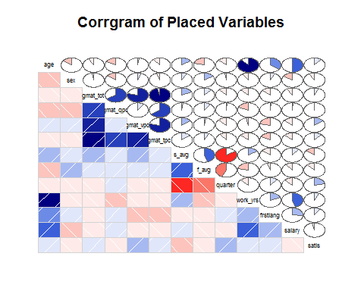

non_placed <- mba_Sal.df[ which(mba_Sal.df$salary==0) , ]   
nonplaced <- xtabs(~ non_placed$gmat_tot+non_placed$f_avg, data=non_placed)  
View(nonplaced)  
prop.table(nonplaced)

## non_placed$f_avg  
## non_placed$gmat_tot 0 2 2.25 2.5 2.67  
## 450 0.00000000 0.01111111 0.00000000 0.00000000 0.00000000  
## 480 0.00000000 0.00000000 0.00000000 0.00000000 0.00000000  
## 510 0.00000000 0.00000000 0.01111111 0.00000000 0.00000000  
## 530 0.00000000 0.00000000 0.00000000 0.01111111 0.00000000  
## 540 0.00000000 0.00000000 0.00000000 0.00000000 0.00000000  
## 550 0.00000000 0.00000000 0.00000000 0.00000000 0.00000000  
## 560 0.00000000 0.00000000 0.00000000 0.01111111 0.00000000  
## 570 0.00000000 0.00000000 0.00000000 0.02222222 0.01111111  
## 580 0.00000000 0.00000000 0.00000000 0.00000000 0.00000000  
## 590 0.00000000 0.00000000 0.00000000 0.00000000 0.00000000  
## 600 0.00000000 0.00000000 0.01111111 0.00000000 0.00000000  
## 610 0.01111111 0.00000000 0.00000000 0.01111111 0.00000000  
## 620 0.00000000 0.00000000 0.00000000 0.00000000 0.00000000  
## 630 0.00000000 0.00000000 0.00000000 0.01111111 0.00000000  
## 640 0.00000000 0.00000000 0.00000000 0.01111111 0.00000000  
## 650 0.00000000 0.00000000 0.00000000 0.00000000 0.00000000  
## 660 0.00000000 0.01111111 0.00000000 0.00000000 0.00000000  
## 670 0.00000000 0.00000000 0.00000000 0.00000000 0.00000000  
## 680 0.00000000 0.00000000 0.00000000 0.00000000 0.00000000  
## 700 0.00000000 0.01111111 0.00000000 0.00000000 0.00000000  
## 710 0.00000000 0.00000000 0.00000000 0.00000000 0.00000000  
## 720 0.00000000 0.00000000 0.00000000 0.01111111 0.00000000  
## 730 0.00000000 0.00000000 0.00000000 0.00000000 0.00000000  
## 740 0.00000000 0.00000000 0.00000000 0.00000000 0.00000000  
## 750 0.00000000 0.00000000 0.00000000 0.00000000 0.00000000  
## 760 0.00000000 0.00000000 0.00000000 0.00000000 0.00000000  
## non_placed$f_avg  
## non_placed$gmat_tot 2.75 3 3.17 3.2 3.25  
## 450 0.00000000 0.00000000 0.00000000 0.00000000 0.00000000  
## 480 0.00000000 0.00000000 0.00000000 0.00000000 0.01111111  
## 510 0.00000000 0.00000000 0.00000000 0.00000000 0.00000000  
## 530 0.01111111 0.00000000 0.01111111 0.00000000 0.00000000  
## 540 0.01111111 0.00000000 0.00000000 0.00000000 0.01111111  
## 550 0.01111111 0.03333333 0.00000000 0.00000000 0.00000000  
## 560 0.00000000 0.01111111 0.00000000 0.00000000 0.03333333  
## 570 0.00000000 0.01111111 0.00000000 0.00000000 0.01111111  
## 580 0.01111111 0.00000000 0.00000000 0.00000000 0.02222222  
## 590 0.02222222 0.00000000 0.00000000 0.00000000 0.00000000  
## 600 0.00000000 0.02222222 0.00000000 0.00000000 0.00000000  
## 610 0.01111111 0.03333333 0.00000000 0.00000000 0.00000000  
## 620 0.00000000 0.03333333 0.00000000 0.00000000 0.00000000  
## 630 0.00000000 0.01111111 0.00000000 0.00000000 0.03333333  
## 640 0.00000000 0.02222222 0.00000000 0.00000000 0.01111111  
## 650 0.00000000 0.02222222 0.00000000 0.01111111 0.00000000  
## 660 0.00000000 0.01111111 0.00000000 0.00000000 0.00000000  
## 670 0.00000000 0.01111111 0.00000000 0.00000000 0.03333333  
## 680 0.00000000 0.02222222 0.00000000 0.00000000 0.00000000  
## 700 0.00000000 0.00000000 0.00000000 0.00000000 0.01111111  
## 710 0.01111111 0.01111111 0.00000000 0.00000000 0.01111111  
## 720 0.00000000 0.00000000 0.00000000 0.00000000 0.01111111  
## 730 0.01111111 0.00000000 0.00000000 0.00000000 0.00000000  
## 740 0.00000000 0.00000000 0.00000000 0.00000000 0.00000000  
## 750 0.00000000 0.00000000 0.00000000 0.00000000 0.00000000  
## 760 0.00000000 0.01111111 0.00000000 0.00000000 0.00000000  
## non_placed$f_avg  
## non_placed$gmat_tot 3.33 3.4 3.5 3.6 3.67  
## 450 0.00000000 0.00000000 0.00000000 0.00000000 0.00000000  
## 480 0.00000000 0.00000000 0.00000000 0.00000000 0.00000000  
## 510 0.00000000 0.01111111 0.00000000 0.00000000 0.00000000  
## 530 0.00000000 0.00000000 0.00000000 0.00000000 0.00000000  
## 540 0.00000000 0.00000000 0.00000000 0.00000000 0.00000000  
## 550 0.00000000 0.00000000 0.00000000 0.00000000 0.00000000  
## 560 0.00000000 0.00000000 0.01111111 0.01111111 0.00000000  
## 570 0.00000000 0.00000000 0.01111111 0.00000000 0.00000000  
## 580 0.01111111 0.00000000 0.00000000 0.00000000 0.00000000  
## 590 0.00000000 0.00000000 0.00000000 0.00000000 0.00000000  
## 600 0.00000000 0.00000000 0.00000000 0.00000000 0.00000000  
## 610 0.00000000 0.00000000 0.01111111 0.00000000 0.01111111  
## 620 0.00000000 0.00000000 0.01111111 0.00000000 0.00000000  
## 630 0.00000000 0.00000000 0.00000000 0.00000000 0.00000000  
## 640 0.00000000 0.00000000 0.00000000 0.00000000 0.00000000  
## 650 0.00000000 0.00000000 0.00000000 0.00000000 0.00000000  
## 660 0.00000000 0.00000000 0.00000000 0.00000000 0.00000000  
## 670 0.00000000 0.00000000 0.00000000 0.00000000 0.00000000  
## 680 0.00000000 0.00000000 0.01111111 0.00000000 0.00000000  
## 700 0.00000000 0.00000000 0.00000000 0.00000000 0.00000000  
## 710 0.00000000 0.00000000 0.00000000 0.00000000 0.00000000  
## 720 0.00000000 0.00000000 0.00000000 0.00000000 0.00000000  
## 730 0.00000000 0.00000000 0.00000000 0.00000000 0.00000000  
## 740 0.00000000 0.00000000 0.01111111 0.00000000 0.00000000  
## 750 0.00000000 0.00000000 0.01111111 0.00000000 0.00000000  
## 760 0.00000000 0.00000000 0.00000000 0.00000000 0.00000000  
## non_placed$f_avg  
## non_placed$gmat_tot 3.75 3.83 4  
## 450 0.00000000 0.00000000 0.00000000  
## 480 0.00000000 0.00000000 0.00000000  
## 510 0.00000000 0.00000000 0.00000000  
## 530 0.00000000 0.00000000 0.00000000  
## 540 0.00000000 0.00000000 0.01111111  
## 550 0.00000000 0.00000000 0.00000000  
## 560 0.01111111 0.00000000 0.00000000  
## 570 0.00000000 0.00000000 0.01111111  
## 580 0.00000000 0.00000000 0.00000000  
## 590 0.00000000 0.00000000 0.01111111  
## 600 0.00000000 0.00000000 0.00000000  
## 610 0.00000000 0.00000000 0.01111111  
## 620 0.00000000 0.00000000 0.00000000  
## 630 0.00000000 0.00000000 0.00000000  
## 640 0.02222222 0.00000000 0.00000000  
## 650 0.01111111 0.01111111 0.00000000  
## 660 0.01111111 0.00000000 0.00000000  
## 670 0.00000000 0.00000000 0.00000000  
## 680 0.00000000 0.00000000 0.00000000  
## 700 0.00000000 0.00000000 0.00000000  
## 710 0.01111111 0.00000000 0.00000000  
## 720 0.00000000 0.00000000 0.00000000  
## 730 0.00000000 0.00000000 0.00000000  
## 740 0.00000000 0.00000000 0.00000000  
## 750 0.00000000 0.00000000 0.00000000  
## 760 0.00000000 0.00000000 0.00000000

chisq.test(nonplaced)

## Warning in chisq.test(nonplaced): Chi-squared approximation may be  
## incorrect

##   
## Pearson's Chi-squared test  
##   
## data: nonplaced  
## X-squared = 413.82, df = 425, p-value = 0.642

nonplaced <- xtabs(~ non_placed$s_avg+non_placed$f_avg, data=non_placed)  
View(nonplaced)  
prop.table(nonplaced)

## non_placed$f_avg  
## non_placed$s_avg 0 2 2.25 2.5 2.67  
## 2 0.00000000 0.01111111 0.00000000 0.00000000 0.00000000  
## 2.1 0.00000000 0.01111111 0.00000000 0.01111111 0.00000000  
## 2.2 0.00000000 0.00000000 0.01111111 0.00000000 0.00000000  
## 2.3 0.00000000 0.00000000 0.01111111 0.01111111 0.00000000  
## 2.4 0.00000000 0.00000000 0.00000000 0.01111111 0.00000000  
## 2.6 0.00000000 0.01111111 0.00000000 0.00000000 0.00000000  
## 2.7 0.00000000 0.00000000 0.00000000 0.02222222 0.00000000  
## 2.8 0.00000000 0.00000000 0.00000000 0.01111111 0.00000000  
## 2.82 0.00000000 0.00000000 0.00000000 0.01111111 0.00000000  
## 2.9 0.00000000 0.00000000 0.00000000 0.00000000 0.00000000  
## 3 0.00000000 0.00000000 0.00000000 0.01111111 0.00000000  
## 3.08 0.00000000 0.00000000 0.00000000 0.00000000 0.00000000  
## 3.09 0.00000000 0.00000000 0.00000000 0.00000000 0.00000000  
## 3.1 0.00000000 0.00000000 0.00000000 0.00000000 0.00000000  
## 3.17 0.00000000 0.00000000 0.00000000 0.00000000 0.00000000  
## 3.2 0.00000000 0.00000000 0.00000000 0.00000000 0.00000000  
## 3.25 0.01111111 0.00000000 0.00000000 0.00000000 0.00000000  
## 3.27 0.00000000 0.00000000 0.00000000 0.00000000 0.00000000  
## 3.3 0.00000000 0.00000000 0.00000000 0.00000000 0.01111111  
## 3.38 0.00000000 0.00000000 0.00000000 0.00000000 0.00000000  
## 3.4 0.00000000 0.00000000 0.00000000 0.00000000 0.00000000  
## 3.45 0.00000000 0.00000000 0.00000000 0.00000000 0.00000000  
## 3.5 0.00000000 0.00000000 0.00000000 0.00000000 0.00000000  
## 3.6 0.00000000 0.00000000 0.00000000 0.00000000 0.00000000  
## 3.64 0.00000000 0.00000000 0.00000000 0.00000000 0.00000000  
## 3.8 0.00000000 0.00000000 0.00000000 0.00000000 0.00000000  
## 3.9 0.00000000 0.00000000 0.00000000 0.00000000 0.00000000  
## non_placed$f_avg  
## non_placed$s_avg 2.75 3 3.17 3.2 3.25  
## 2 0.00000000 0.00000000 0.00000000 0.00000000 0.00000000  
## 2.1 0.00000000 0.00000000 0.00000000 0.00000000 0.00000000  
## 2.2 0.00000000 0.00000000 0.00000000 0.00000000 0.00000000  
## 2.3 0.00000000 0.00000000 0.00000000 0.00000000 0.00000000  
## 2.4 0.01111111 0.00000000 0.00000000 0.00000000 0.00000000  
## 2.6 0.00000000 0.00000000 0.00000000 0.00000000 0.00000000  
## 2.7 0.03333333 0.02222222 0.00000000 0.00000000 0.01111111  
## 2.8 0.02222222 0.04444444 0.00000000 0.00000000 0.02222222  
## 2.82 0.00000000 0.00000000 0.00000000 0.00000000 0.00000000  
## 2.9 0.01111111 0.04444444 0.00000000 0.00000000 0.04444444  
## 3 0.01111111 0.05555556 0.00000000 0.01111111 0.02222222  
## 3.08 0.00000000 0.00000000 0.00000000 0.00000000 0.01111111  
## 3.09 0.00000000 0.00000000 0.01111111 0.00000000 0.00000000  
## 3.1 0.00000000 0.03333333 0.00000000 0.00000000 0.01111111  
## 3.17 0.00000000 0.00000000 0.00000000 0.00000000 0.00000000  
## 3.2 0.00000000 0.02222222 0.00000000 0.00000000 0.02222222  
## 3.25 0.00000000 0.00000000 0.00000000 0.00000000 0.00000000  
## 3.27 0.00000000 0.00000000 0.00000000 0.00000000 0.00000000  
## 3.3 0.01111111 0.01111111 0.00000000 0.00000000 0.03333333  
## 3.38 0.00000000 0.01111111 0.00000000 0.00000000 0.00000000  
## 3.4 0.00000000 0.02222222 0.00000000 0.00000000 0.01111111  
## 3.45 0.00000000 0.00000000 0.00000000 0.00000000 0.00000000  
## 3.5 0.00000000 0.00000000 0.00000000 0.00000000 0.00000000  
## 3.6 0.00000000 0.00000000 0.00000000 0.00000000 0.01111111  
## 3.64 0.00000000 0.00000000 0.00000000 0.00000000 0.00000000  
## 3.8 0.00000000 0.00000000 0.00000000 0.00000000 0.00000000  
## 3.9 0.00000000 0.00000000 0.00000000 0.00000000 0.00000000  
## non_placed$f_avg  
## non_placed$s_avg 3.33 3.4 3.5 3.6 3.67  
## 2 0.00000000 0.00000000 0.00000000 0.00000000 0.00000000  
## 2.1 0.00000000 0.00000000 0.00000000 0.00000000 0.00000000  
## 2.2 0.00000000 0.00000000 0.00000000 0.00000000 0.00000000  
## 2.3 0.00000000 0.00000000 0.00000000 0.00000000 0.00000000  
## 2.4 0.00000000 0.00000000 0.00000000 0.00000000 0.00000000  
## 2.6 0.00000000 0.00000000 0.00000000 0.00000000 0.00000000  
## 2.7 0.00000000 0.00000000 0.00000000 0.00000000 0.00000000  
## 2.8 0.00000000 0.00000000 0.00000000 0.00000000 0.00000000  
## 2.82 0.00000000 0.00000000 0.00000000 0.00000000 0.00000000  
## 2.9 0.00000000 0.00000000 0.00000000 0.00000000 0.00000000  
## 3 0.00000000 0.00000000 0.00000000 0.00000000 0.00000000  
## 3.08 0.00000000 0.00000000 0.00000000 0.00000000 0.00000000  
## 3.09 0.00000000 0.00000000 0.01111111 0.00000000 0.00000000  
## 3.1 0.00000000 0.00000000 0.01111111 0.00000000 0.01111111  
## 3.17 0.00000000 0.00000000 0.01111111 0.00000000 0.00000000  
## 3.2 0.00000000 0.00000000 0.00000000 0.00000000 0.00000000  
## 3.25 0.00000000 0.00000000 0.00000000 0.00000000 0.00000000  
## 3.27 0.00000000 0.01111111 0.00000000 0.00000000 0.00000000  
## 3.3 0.00000000 0.00000000 0.00000000 0.00000000 0.00000000  
## 3.38 0.00000000 0.00000000 0.00000000 0.00000000 0.00000000  
## 3.4 0.00000000 0.00000000 0.03333333 0.00000000 0.00000000  
## 3.45 0.00000000 0.00000000 0.00000000 0.00000000 0.00000000  
## 3.5 0.00000000 0.00000000 0.01111111 0.00000000 0.00000000  
## 3.6 0.00000000 0.00000000 0.00000000 0.01111111 0.00000000  
## 3.64 0.01111111 0.00000000 0.00000000 0.00000000 0.00000000  
## 3.8 0.00000000 0.00000000 0.00000000 0.00000000 0.00000000  
## 3.9 0.00000000 0.00000000 0.00000000 0.00000000 0.00000000  
## non_placed$f_avg  
## non_placed$s_avg 3.75 3.83 4  
## 2 0.00000000 0.00000000 0.00000000  
## 2.1 0.00000000 0.00000000 0.00000000  
## 2.2 0.00000000 0.00000000 0.00000000  
## 2.3 0.00000000 0.00000000 0.00000000  
## 2.4 0.00000000 0.00000000 0.00000000  
## 2.6 0.00000000 0.00000000 0.00000000  
## 2.7 0.00000000 0.00000000 0.00000000  
## 2.8 0.00000000 0.00000000 0.00000000  
## 2.82 0.00000000 0.00000000 0.00000000  
## 2.9 0.00000000 0.00000000 0.00000000  
## 3 0.00000000 0.00000000 0.00000000  
## 3.08 0.00000000 0.00000000 0.00000000  
## 3.09 0.00000000 0.00000000 0.00000000  
## 3.1 0.00000000 0.00000000 0.00000000  
## 3.17 0.00000000 0.00000000 0.00000000  
## 3.2 0.00000000 0.00000000 0.00000000  
## 3.25 0.00000000 0.00000000 0.00000000  
## 3.27 0.01111111 0.00000000 0.00000000  
## 3.3 0.02222222 0.00000000 0.01111111  
## 3.38 0.00000000 0.00000000 0.00000000  
## 3.4 0.01111111 0.00000000 0.00000000  
## 3.45 0.00000000 0.01111111 0.00000000  
## 3.5 0.00000000 0.00000000 0.01111111  
## 3.6 0.01111111 0.00000000 0.01111111  
## 3.64 0.00000000 0.00000000 0.00000000  
## 3.8 0.00000000 0.00000000 0.01111111  
## 3.9 0.01111111 0.00000000 0.00000000

chisq.test(nonplaced)

## Warning in chisq.test(nonplaced): Chi-squared approximation may be  
## incorrect

##   
## Pearson's Chi-squared test  
##   
## data: nonplaced  
## X-squared = 722.17, df = 442, p-value = 7.981e-16

nonplaced <- xtabs(~ non_placed$work_yrs+non_placed$f_avg, data=non_placed)  
View(nonplaced)  
prop.table(nonplaced)

## non_placed$f_avg  
## non_placed$work_yrs 0 2 2.25 2.5 2.67  
## 0 0.00000000 0.00000000 0.00000000 0.00000000 0.00000000  
## 1 0.00000000 0.01111111 0.00000000 0.01111111 0.01111111  
## 2 0.00000000 0.01111111 0.01111111 0.02222222 0.00000000  
## 3 0.00000000 0.00000000 0.00000000 0.01111111 0.00000000  
## 4 0.00000000 0.01111111 0.00000000 0.02222222 0.00000000  
## 5 0.00000000 0.00000000 0.01111111 0.01111111 0.00000000  
## 6 0.00000000 0.00000000 0.00000000 0.00000000 0.00000000  
## 7 0.00000000 0.00000000 0.00000000 0.01111111 0.00000000  
## 8 0.00000000 0.00000000 0.00000000 0.00000000 0.00000000  
## 9 0.00000000 0.00000000 0.00000000 0.00000000 0.00000000  
## 10 0.00000000 0.00000000 0.00000000 0.00000000 0.00000000  
## 11 0.01111111 0.00000000 0.00000000 0.00000000 0.00000000  
## 12 0.00000000 0.00000000 0.00000000 0.00000000 0.00000000  
## 13 0.00000000 0.00000000 0.00000000 0.00000000 0.00000000  
## 16 0.00000000 0.00000000 0.00000000 0.00000000 0.00000000  
## 18 0.00000000 0.00000000 0.00000000 0.00000000 0.00000000  
## 22 0.00000000 0.00000000 0.00000000 0.00000000 0.00000000  
## non_placed$f_avg  
## non_placed$work_yrs 2.75 3 3.17 3.2 3.25  
## 0 0.00000000 0.01111111 0.00000000 0.00000000 0.00000000  
## 1 0.01111111 0.04444444 0.00000000 0.00000000 0.02222222  
## 2 0.03333333 0.05555556 0.00000000 0.00000000 0.02222222  
## 3 0.03333333 0.04444444 0.00000000 0.00000000 0.04444444  
## 4 0.00000000 0.03333333 0.01111111 0.00000000 0.02222222  
## 5 0.00000000 0.02222222 0.00000000 0.00000000 0.05555556  
## 6 0.01111111 0.00000000 0.00000000 0.00000000 0.00000000  
## 7 0.01111111 0.01111111 0.00000000 0.00000000 0.00000000  
## 8 0.00000000 0.00000000 0.00000000 0.00000000 0.01111111  
## 9 0.00000000 0.00000000 0.00000000 0.00000000 0.00000000  
## 10 0.00000000 0.00000000 0.00000000 0.00000000 0.00000000  
## 11 0.00000000 0.01111111 0.00000000 0.00000000 0.00000000  
## 12 0.00000000 0.01111111 0.00000000 0.00000000 0.01111111  
## 13 0.00000000 0.01111111 0.00000000 0.00000000 0.00000000  
## 16 0.00000000 0.01111111 0.00000000 0.00000000 0.00000000  
## 18 0.00000000 0.00000000 0.00000000 0.01111111 0.00000000  
## 22 0.00000000 0.00000000 0.00000000 0.00000000 0.01111111  
## non_placed$f_avg  
## non_placed$work_yrs 3.33 3.4 3.5 3.6 3.67  
## 0 0.00000000 0.00000000 0.00000000 0.00000000 0.00000000  
## 1 0.00000000 0.00000000 0.02222222 0.00000000 0.00000000  
## 2 0.00000000 0.00000000 0.03333333 0.00000000 0.00000000  
## 3 0.01111111 0.00000000 0.01111111 0.00000000 0.00000000  
## 4 0.00000000 0.00000000 0.00000000 0.00000000 0.00000000  
## 5 0.00000000 0.01111111 0.00000000 0.01111111 0.00000000  
## 6 0.00000000 0.00000000 0.00000000 0.00000000 0.00000000  
## 7 0.00000000 0.00000000 0.00000000 0.00000000 0.01111111  
## 8 0.00000000 0.00000000 0.00000000 0.00000000 0.00000000  
## 9 0.00000000 0.00000000 0.01111111 0.00000000 0.00000000  
## 10 0.00000000 0.00000000 0.00000000 0.00000000 0.00000000  
## 11 0.00000000 0.00000000 0.00000000 0.00000000 0.00000000  
## 12 0.00000000 0.00000000 0.00000000 0.00000000 0.00000000  
## 13 0.00000000 0.00000000 0.00000000 0.00000000 0.00000000  
## 16 0.00000000 0.00000000 0.00000000 0.00000000 0.00000000  
## 18 0.00000000 0.00000000 0.00000000 0.00000000 0.00000000  
## 22 0.00000000 0.00000000 0.00000000 0.00000000 0.00000000  
## non_placed$f_avg  
## non_placed$work_yrs 3.75 3.83 4  
## 0 0.00000000 0.00000000 0.00000000  
## 1 0.00000000 0.00000000 0.00000000  
## 2 0.03333333 0.01111111 0.01111111  
## 3 0.00000000 0.00000000 0.00000000  
## 4 0.00000000 0.00000000 0.00000000  
## 5 0.00000000 0.00000000 0.01111111  
## 6 0.01111111 0.00000000 0.00000000  
## 7 0.01111111 0.00000000 0.00000000  
## 8 0.00000000 0.00000000 0.01111111  
## 9 0.00000000 0.00000000 0.00000000  
## 10 0.01111111 0.00000000 0.00000000  
## 11 0.00000000 0.00000000 0.00000000  
## 12 0.00000000 0.00000000 0.00000000  
## 13 0.00000000 0.00000000 0.00000000  
## 16 0.00000000 0.00000000 0.00000000  
## 18 0.00000000 0.00000000 0.00000000  
## 22 0.00000000 0.00000000 0.01111111

chisq.test(nonplaced)

## Warning in chisq.test(nonplaced): Chi-squared approximation may be  
## incorrect

##   
## Pearson's Chi-squared test  
##   
## data: nonplaced  
## X-squared = 292.42, df = 272, p-value = 0.1886

library(ggplot2)  
ggplot(placed, aes(x = salary, fill = salary)) + geom_bar()

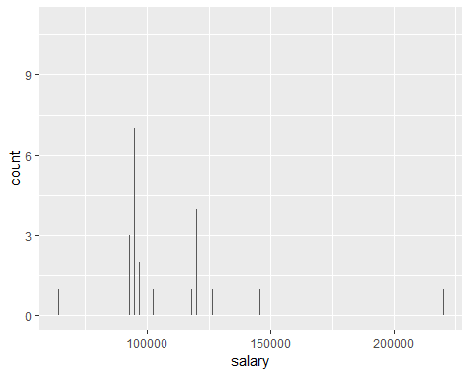

ggplot(placed, aes(x = gmat_tot, fill = gmat_tot)) + geom_bar()

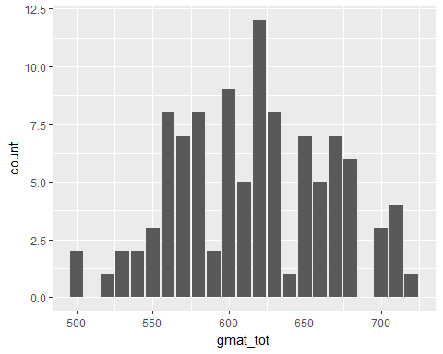

library(ggplot2)  
ggplot(non_placed, aes(x = gmat_tot, fill = gmat_tot)) + geom_bar()

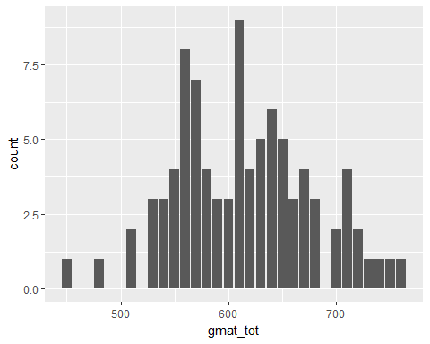

mba_Sal.df$sal <- ifelse(mba_Sal.df$salary==998,0,  
 (ifelse(mba_Sal.df$salary==999,0,  
 (ifelse(mba_Sal.df$salary==0,0, 1  
 )))))  
   
mba_Sal.data = glm(formula = mba_Sal.df$sal ~ mba_Sal.df$gmat_tot+mba_Sal.df$f_avg+mba_Sal.df$s_avg+mba_Sal.df$work_yrs+mba_Sal.df$age, data = placed, family = binomial)  
summary(mba_Sal.data)

##   
## Call:  
## glm(formula = mba_Sal.df$sal ~ mba_Sal.df$gmat_tot + mba_Sal.df$f_avg +   
## mba_Sal.df$s_avg + mba_Sal.df$work_yrs + mba_Sal.df$age,   
## family = binomial, data = placed)  
##   
## Deviance Residuals:   
## Min 1Q Median 3Q Max   
## -1.4775 -0.9878 -0.7458 1.2585 2.1475   
##   
## Coefficients:  
## Estimate Std. Error z value Pr(>|z|)   
## (Intercept) 3.862831 2.434526 1.587 0.11258   
## mba_Sal.df$gmat_tot -0.002919 0.002345 -1.244 0.21336   
## mba_Sal.df$f_avg -0.235651 0.288872 -0.816 0.41464   
## mba_Sal.df$s_avg 1.148470 0.420673 2.730 0.00633 **  
## mba_Sal.df$work_yrs 0.149474 0.085398 1.750 0.08006 .   
## mba_Sal.df$age -0.216945 0.077772 -2.790 0.00528 **  
## ---  
## Signif. codes: 0 '***' 0.001 '**' 0.01 '*' 0.05 '.' 0.1 ' ' 1  
##   
## (Dispersion parameter for binomial family taken to be 1)  
##   
## Null deviance: 362.79 on 273 degrees of freedom  
## Residual deviance: 345.39 on 268 degrees of freedom  
## AIC: 357.39  
##   
## Number of Fisher Scoring iterations: 4